Lab 7 - Activity 1: Packet Tracer – Configure OSPF

Student No:C18322011 Name: Omair Duadu

This activity allows you to test your OSPF configuration skills. Refer to your lab notes and previous NetAcad content if you need assistance. Do not copy configuration commands from the Internet as they may not suit the current configuration context. Always refer to NetAcad content for information in the first instance.

1. Topology

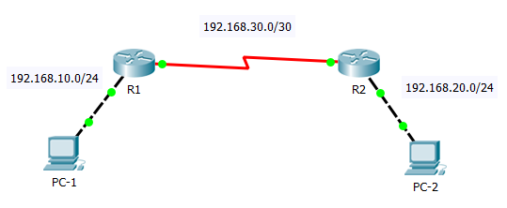

1. Addressing Table

|  |  |  |  |  |
| --- | --- | --- | --- | --- |
| Device | Interface | IPv4 Address | Subnet Mask | Default Gateway |
| R1 | G0/0 | 192.168.10.1 | 255.255.255.0 | N/A |
| S0/0/0 | 192.168.30.1 | 255.255.255.252 | N/A |
| R2 | G/0/0 | 192.168.20.1 | 255.255.255.0 | N/A |
| S0/0/0 | 192.168.30.2 | 255.255.255.252 | N/A |
| PC-1 | NIC | 192.168.10.2 | 255.255.255.0 | 192.168.10.1 |
| PC-2 | NIC | 192.168.20.2 | 255.255.255.0 | 192.168.20.1 |

1. Scenario

PC-1 cannot ping PC-2. Configure OSPF Routing on R1 and R2 and test connectivity between PC-1 and PC-2. You do not need to configure IP addresses on the PCs or the Routers. This has been already done.

Requirements

**OSPF Routing**

* Configure OSPFv2 area 0 on **R1**.
  1. Use process ID 10.
  2. Advertise directly connected networks.
  3. Prevent routing updates from being sent across the LAN interfaces.
* Configure OSPFv2 area 0 on **R2**.
  1. Use process ID 10.
  2. Advertise directly connected networks.
  3. Prevent routing updates from being sent across the LAN interfaces.

**Verify OSPF operation**

* Verify that OSPF configuration works as expected on R1 and R2 using the **show ip protocols** command.
* Use the **show ip route** command to verify that R1 and R2 have routes to each other's LANs that have been learned dynamically using OSPF.

**Verify End-to-End Connectivity**

* **Ping** between PC-1 and PC-2 to test connectivity. Use ping from PC-1 command line.

Take a screen shot of the **ping output** on PC-1 command line and paste it in below.

Screen shot:

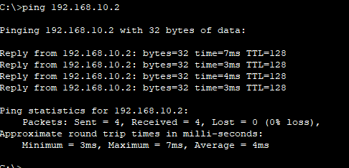

**Record the OSPF configurations for R1 and R2 for reference**

**R1 OSPF**

_______________________________________________________

_______________________________________________________

_______________________________________________________

**R2 OSPF**

_______________________________________________________

_______________________________________________________

_______________________________________________________